**SNS COLLEGE OF TECHNOLOGY**

**Coimbatore-641035**

Department of Electronics and Communication Engineering

IOT Assignment

**NAME:**DEEPTI.S

SMART HOME CIRCUIT :

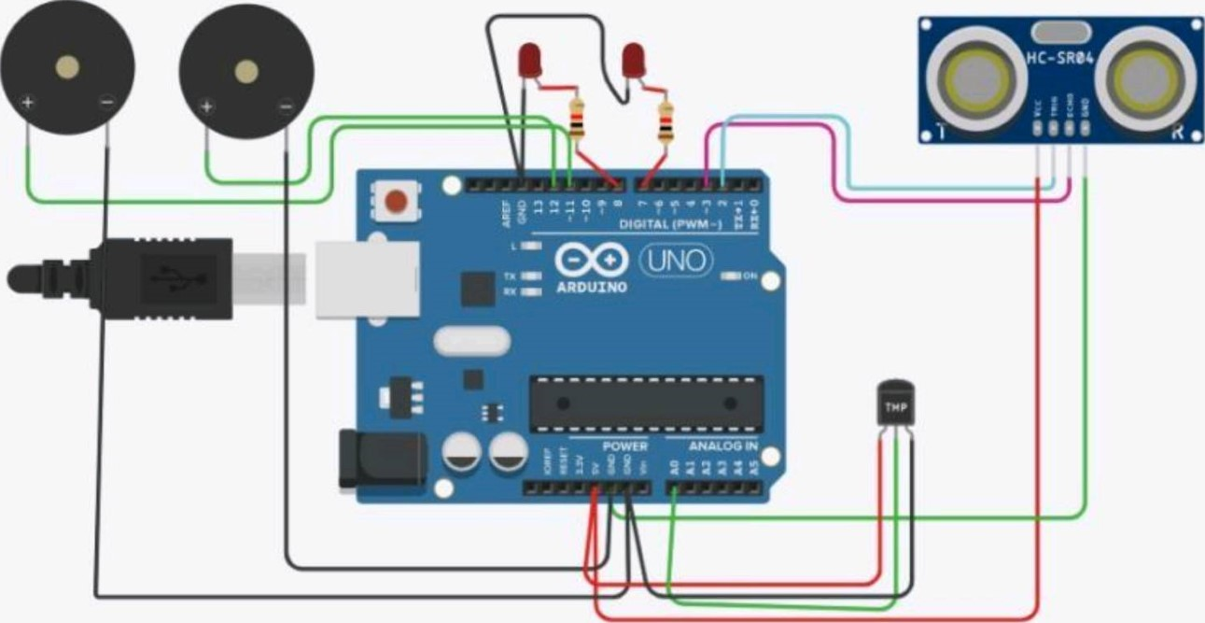

CODE:

int t=2;

int e=3;

void setup()

{

serial.begin(9600);

pinMode(t,OUTPUT);

pinMode(e,INPUT);

pinMode(12,OUTPUT);

}

void loop()

{

//ultrasonic sensor

digitalWrite(t,LOW);

digitalWrite(t,HIGH);

delayMicroseconds(20);

digitalWrite(t,LOW);

float dur=pulseIn(e,HIGH);

float dis=(dur*0.0343)/2;

Serial.println(“Distance is:”);

Serial.println(dis);

//LED ON

if(dis>=100) //(in terms of centimeter)

{

digitalWrite(8,HIGH);

digitalWrite(7,HIGH);

}

//Buzzer for ultrasonic sensor

if(dis>=100)

{

for(int i=0;i<30000;i=i+10)

{

tone(12,i);

delay(1000);

noTone(12);

delay(1000);

}

}

//Temperature sensor

Double a=analogRead(A0);

Double t=(((a/1024)*5)-0.5)*100;

Serial.print(“Temp Value:”);

Serial.println(t);

Delay(1000);

//LED

if(t>=100)//(in terms ofcelsius)

{

digitalWrite(8,HIGH);

digitalWrite(7,HIGH);

//Buzzer for temperature sensor

if(t>=100)

{

for(int i=0;i<=30000;i=i+10)

{

tone(12,i);

delay(1000);

noTone(12);

delay(1000);

}

}

//LED OFF

if(t<100)

{

digitalWrite(8,LOW);

digitalWrite(7,LOW);

}

}